**Map Points:**

# Lavender

# *Lavandula*

# 49°15'16.2"N 122°59'53.7"W

# Lavender is a perennial shrub with purple flowers that bloom during the summer.

# cid:ed2e88ec-04a2-4b77-b165-186e3a286d88@bcit.ca

# Kinnikinnick

## *Arctostaphylos uva-ursi*

# 49°15'13.4"N 122°59'53.4"W

# Kinnikinnick is an evergreen ground cover. It has small white or pink flowers that typically bloom in May and June, and red berries later in the season. Kinnikinnick attracts butterflies and other pollinators. It’s a food source for wildlife all year round.

# Q:\Projects\ISSP\Kinnikkk.jpg

# Coastal Strawberry

# *Fragaria chiloensis*

# 49°15'13.2"N 123°00'04.8"W

# This evergreen ground cover has three leaves, and white flowers that bloom in the summer. The coastal strawberry attracts pollinators. It’s a food source for wildlife in the spring and summer.

# Q:\Projects\ISSP\Strawberry.jpg

1. Salal

***Gaultheria shallon***

49.251508, -123.003891

Salal is a perennial evergreen shrub.Salal attracts pollinators and hummingbirds. It’s a food source for wildlife all year round.

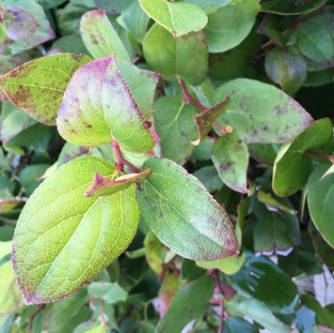

1. Snowberry

*Symphoricarpos albus*

*49°15'13.2"N 122°59'53.4"W*

These shrubs have white flowers in spring, and white berries through the fall and winter.

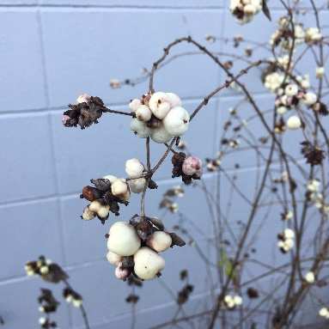

# *Sword Ferns*

# *Polystichum munitum*

# *49.2516282,-123.0003427*

# Sword fern gets its name from its elongated blade-like fronds. The robust, handsome leaves can grow several feet long and the plant can have as many as a hundred leaves. This evergreen fern can be used to prevent erosion on slopes. Sword ferns are a food source for wildlife all year round.

# cid:3a851366-eeb4-4169-918e-adc73529c58c@bcit.ca

# Western Red Cedar

# *Thuja plicata*

# 49.2485308,-123.0000255

Western Red Cedar is a large evergreen tree, they can grow to 120 – 150 feet. Western Red cedar are a food source for wildlife all year round. Because cedar is resistant to decay it was used for building long houses, canoes and other items. The bark can be shredded and used to weave.

# cid:e2f2063c-665b-4fc0-a76e-70bc0cf6130a@bcit.ca

# The Three Sisters

# Tiered Gardens (SW1) 49.250428, -123.002965

# Coming Soon – Corn, Beans and Squash are the Three Sisters.

# cid:dfe4df1b-7c61-45f1-9fe3-950fc23903ec@bcit.ca

# The Indigenous Initiatives Gathering Place

# (SW1) 49.2508575,-123.0030182

# The Indigenous Gathering Place is a comfortable, welcoming and safe space for students, families and staff. Mi Chap Tukw, the BCIT Indigenous Gathering Place (IGP) is located on the Burnaby campus at SW1-1521.

# Video: https://youtu.be/49BCc6FJEK8

# 

# The House Post (cedar tree gifted by Squamish First Nation)

# (SW1) 49.2511455,-123.0031097

# This Indigenous house post was created by Aron Nelson-Moody. House posts were part of traditional Coat Salish longhouses. This house post was commissioned to mark BCIT's 50th anniversary.

# Video: <https://youtu.be/7g2ku5qT0ug>

# Link: <https://housepost.commons.bcit.ca/>

# 

# 

# The Sweat Lodge

# (49.245982, -122.998682)

# A sweat lodge ceremony is a gentle and caring approach to the cleansing of your mind, body, and spirit. Through the experience, your body is cleansed of the toxins within your body, which aids in the de-stressing of your mental, emotional, physical and spiritual well-being.

# Link: https://www.bcit.ca/indigenous-services/events/traditional-ceremonies/

# 

# New Plants (draft)

1. Stika Spruce

*Picea sitchensis*

(Lot O: location TBD)

The Sitka Spruce is a conifer tree that can grow to 180 – 225 feet tall.

1. Big Leaf Maple

*Acer macrophyllum*

(Lot O: location TBD)

Big Leaf Maples typically grow to 30 – 75 feet, and may live to be 200 years old. It is a food source for wildlife.

1. Salmonberry

*Rubus Spectabilis*

(Lot O: location TBD)

Salmonberry have pink flowers with five petals in April - May, and yellow-orange berries through May - July. The flowers are attractive to hummingbirds, and the plant is a food source for wildlife in summer.

1. Red Elderberry

*Sambucus racemosa*

(Lot O: location TBD)

Red Elderberry have white flowers in April - July, and bright red berries through July – August. Red Elderberry is used for erosion control. The plant is a food source for wildlife and pollinators.

1. Red-Osier Dogwood

(Lot O: location TBD)

1. Thimbleberry

*Rubus parviflorus*

(Lot O: location TBD)

Thimbleberry have white flowers in May - June, and small red berries through July – September. The plant is a food source for wildlife and pollinators during summer.

1. Evergreen Huckleberry

*Vaccinium ovatum*

(English Walk: location TBD)

Evergreen Huckleberry have pinkish-white flowers in April - May, and purplish-black berries through August – September. The plant is a food source for wildlife and pollinators.